How to Install and Setup DNS Service on Windows Server 2019
Assign a Static IP to the DNS server:
Before you install the DNS server role, make sure that your DNS server has a static IP-address.
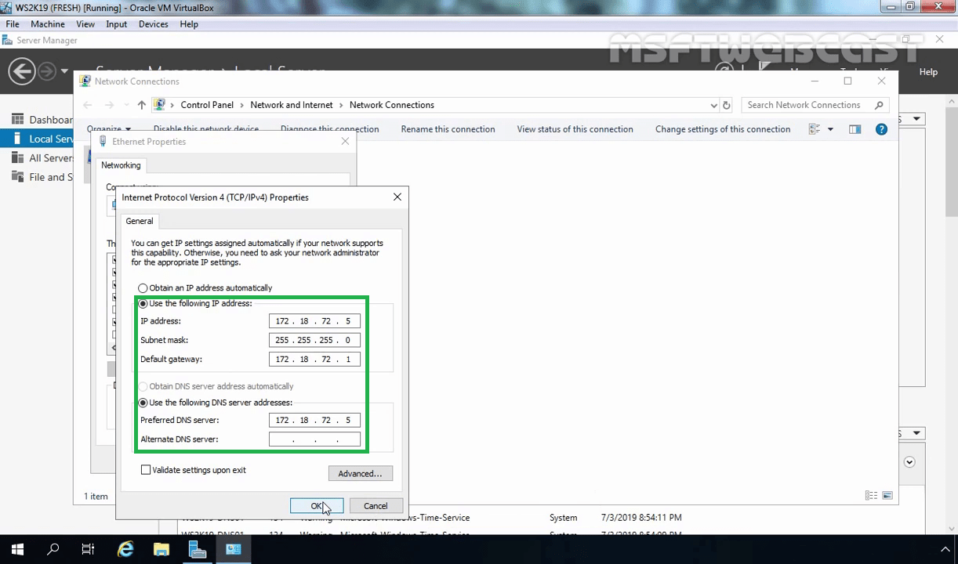
Install the DNS Server Role:
Open the server manager dashboard.
Click on Manage and select Add roles and features.
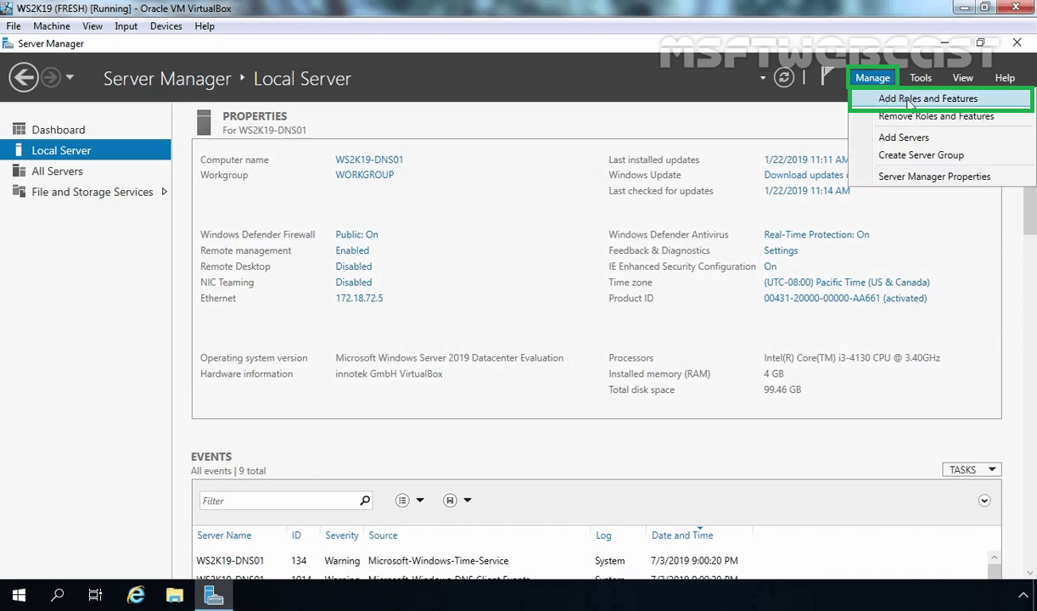
Click on Next on Before you begin console.
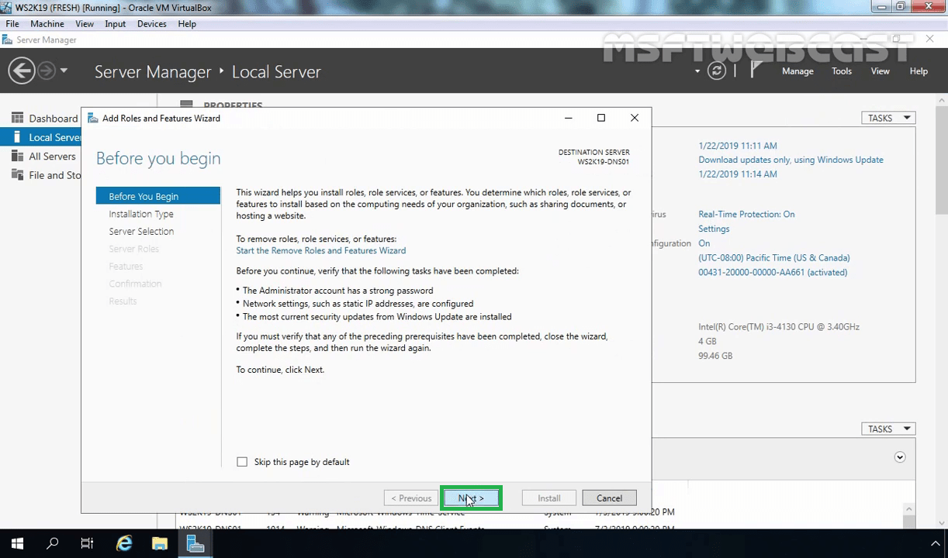
Select Role-based or feature-based installation and click on Next.
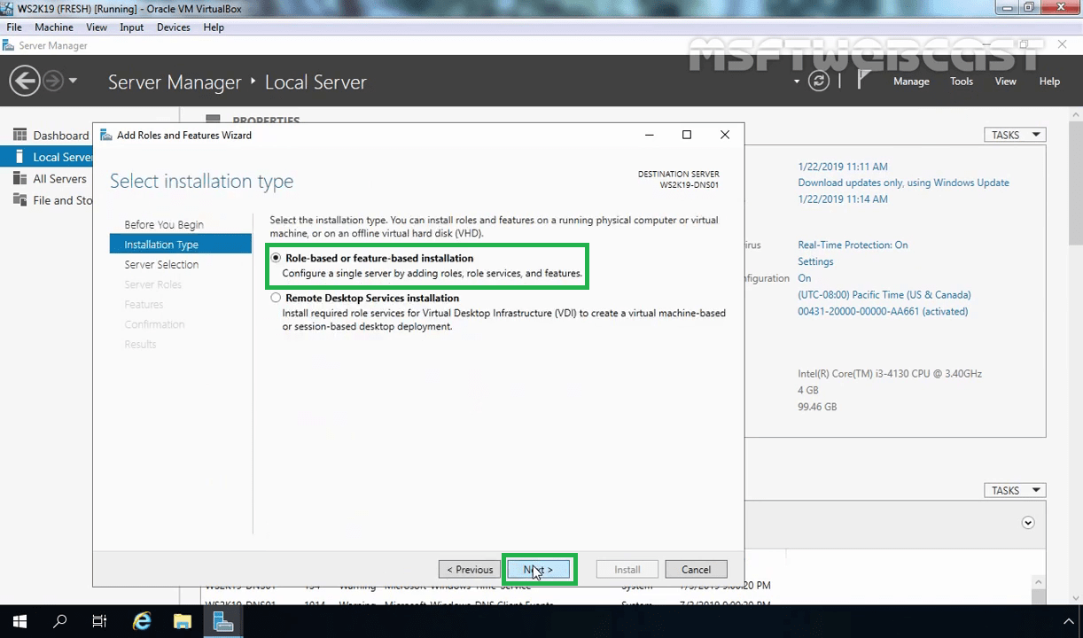
Select the server on which you want to install the DNS server role and click on Next.
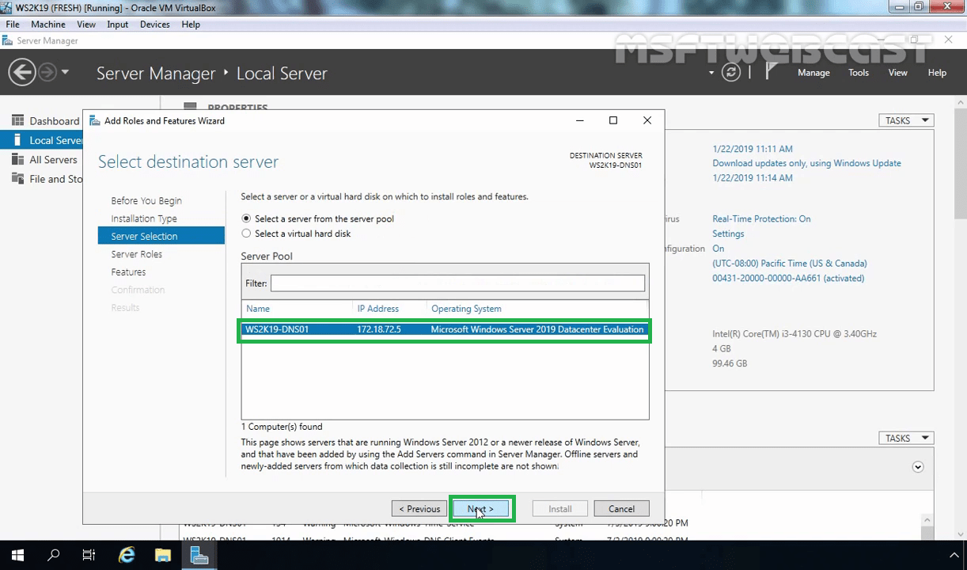
Select the DNS Server role.
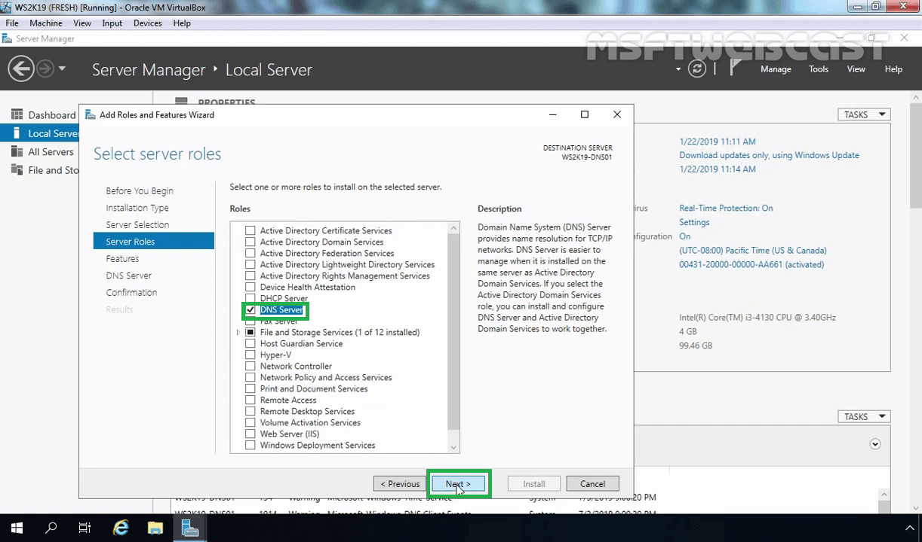
As soon as you choose the DNS role, a new window will pop up. Click Add features to add required features.
After selecting the DNS server role with management tools, click on Next to continue.
No additional features required at this moment. Click on Next.
You can read brief overview information about the DNS server. Click on Next.
Click on Install to start the installation process.
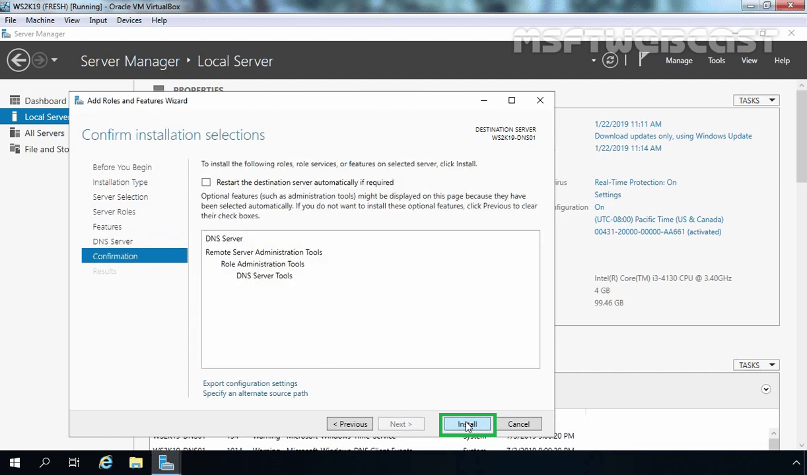
The DNS server role is successfully installed and ready for configuration. Click on Close to close the wizard.
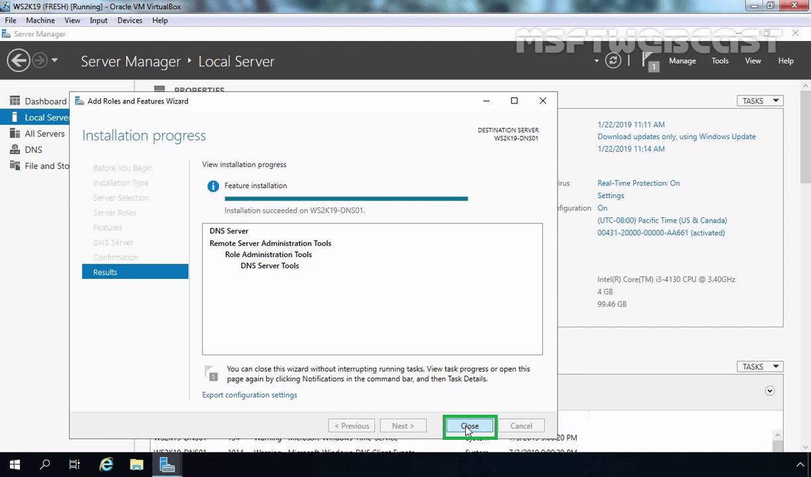
Create a Forward Lookup Zone:
We can create and manage the DNS zone from the DNS management console.
Open the server manager dashboard (If you have closed).
Click on Tools and select DNS.
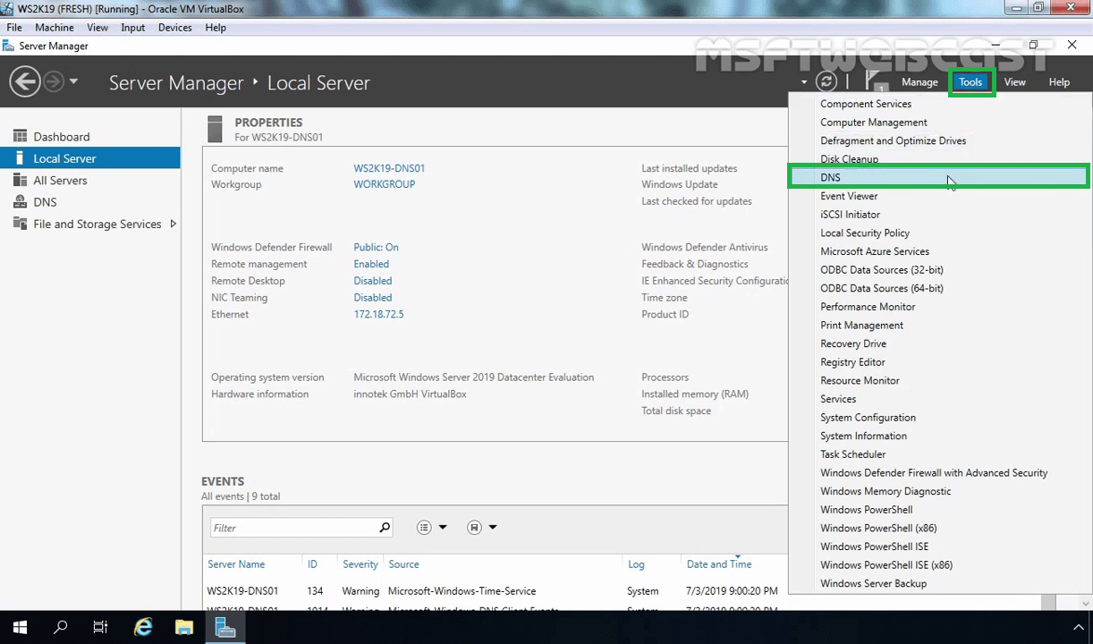
In the DNS Manager console, expand the DNS server.
Right-click on Forward Lookup Zones and select New Zone.
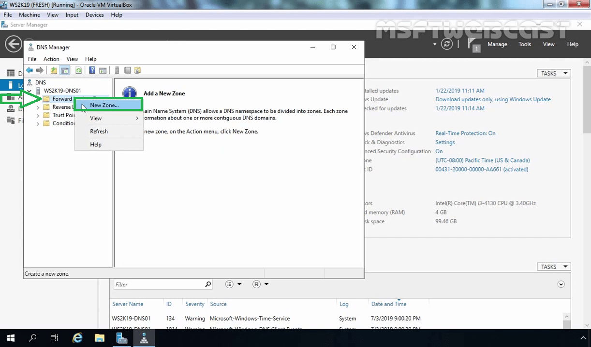
Click on Next on the welcome wizard.
In this step, you can select the type of DNS you want to use. This is our first DNS server that’s why we will select Primary Zone. (The primary zone is a read and write copy of DNS zone hosted by your DNS server.)
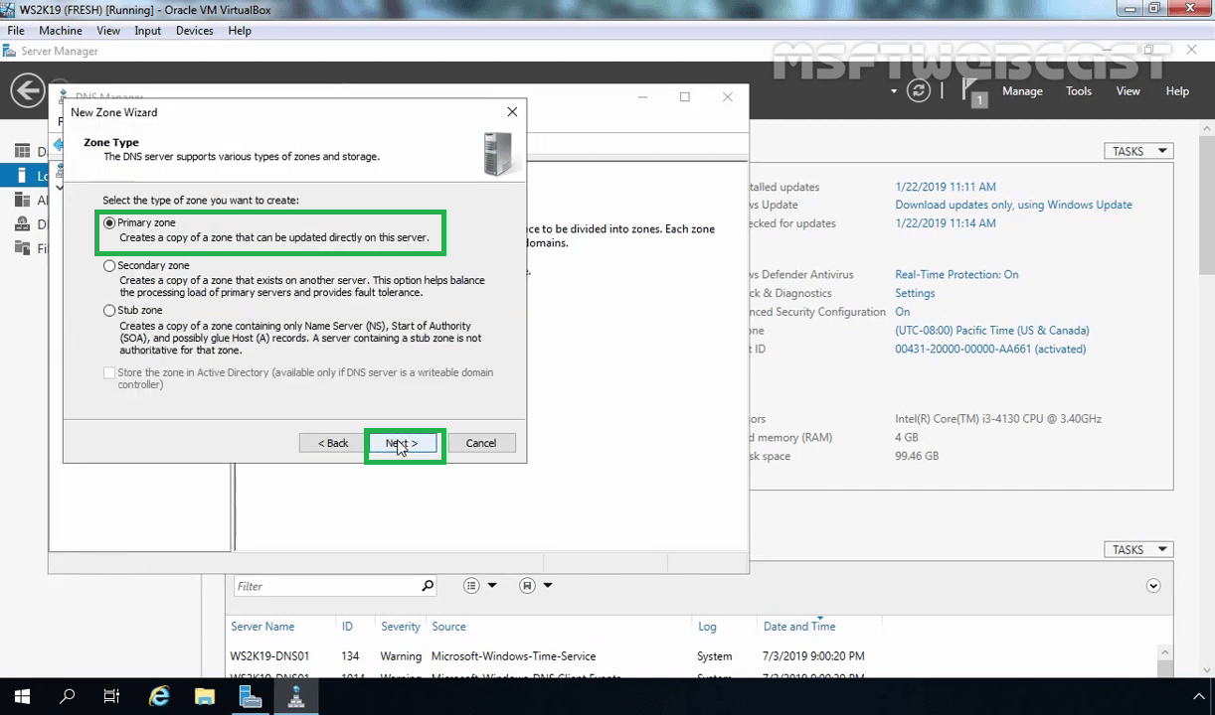
Provide the zone name and click Next. (In our case, it will be msftwebcast.com).
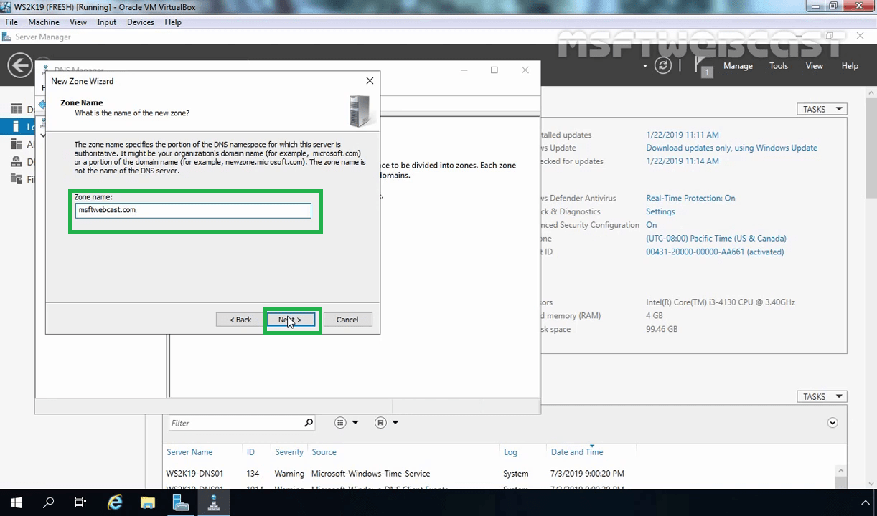
Choose “Create a new file with this filename” with a default file name (msftwebcast.com.dns) and click Next.
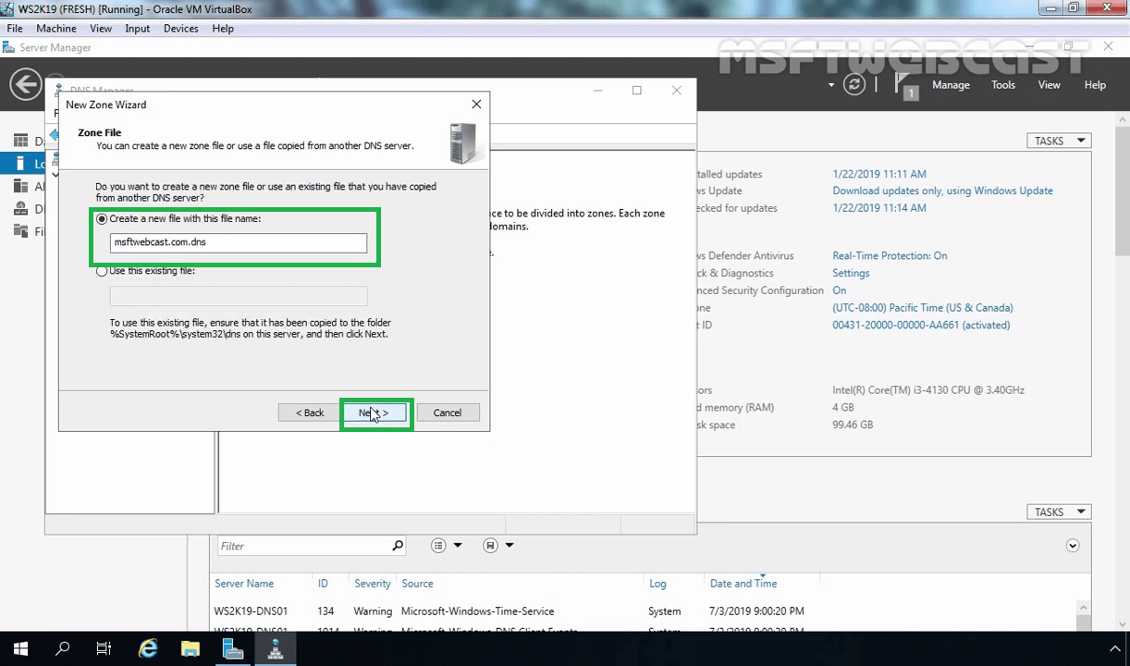
Choose Do not allow dynamic updates and click on Next.
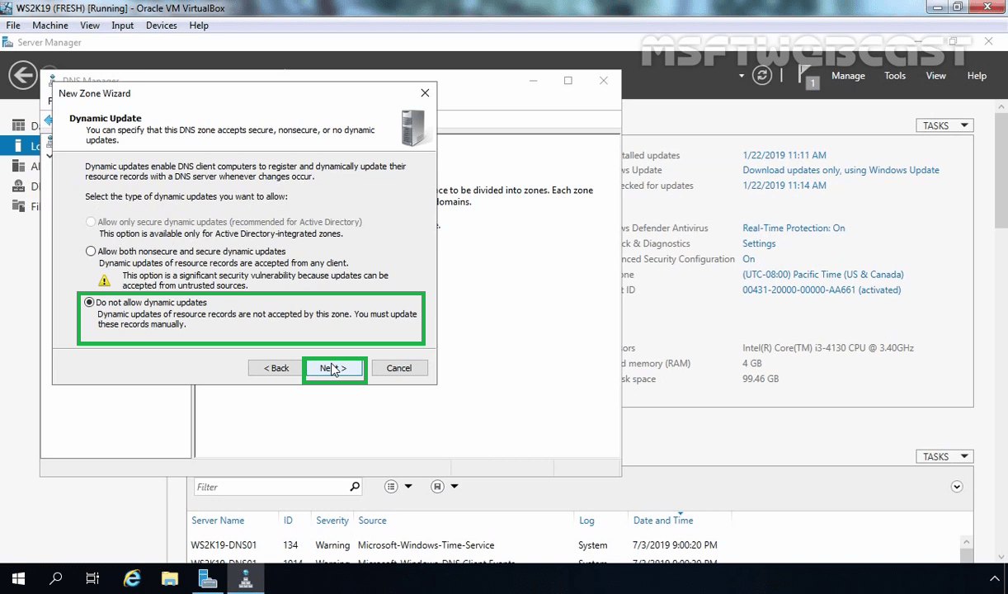
Click on Finish.
That’s all, forward zone created.
Create a Reverse Lookup Zone:
To do this right-click on Reverse Lookup Zone and click on New Zone.
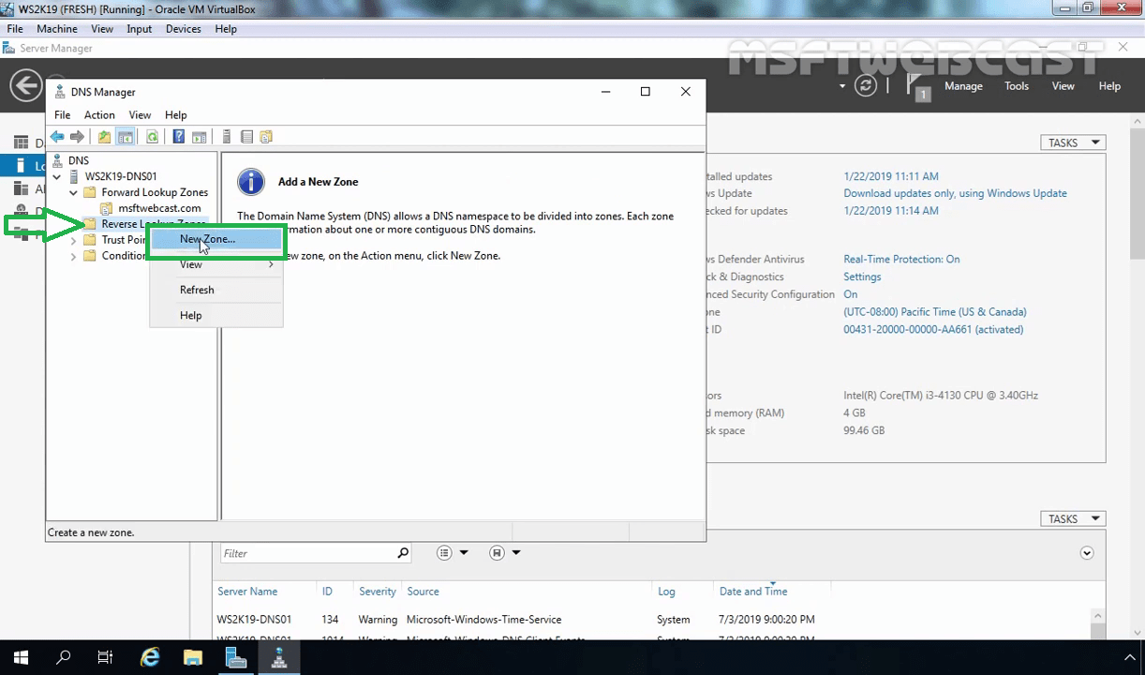
Click on Next.
Select Primary zone and click on Next.
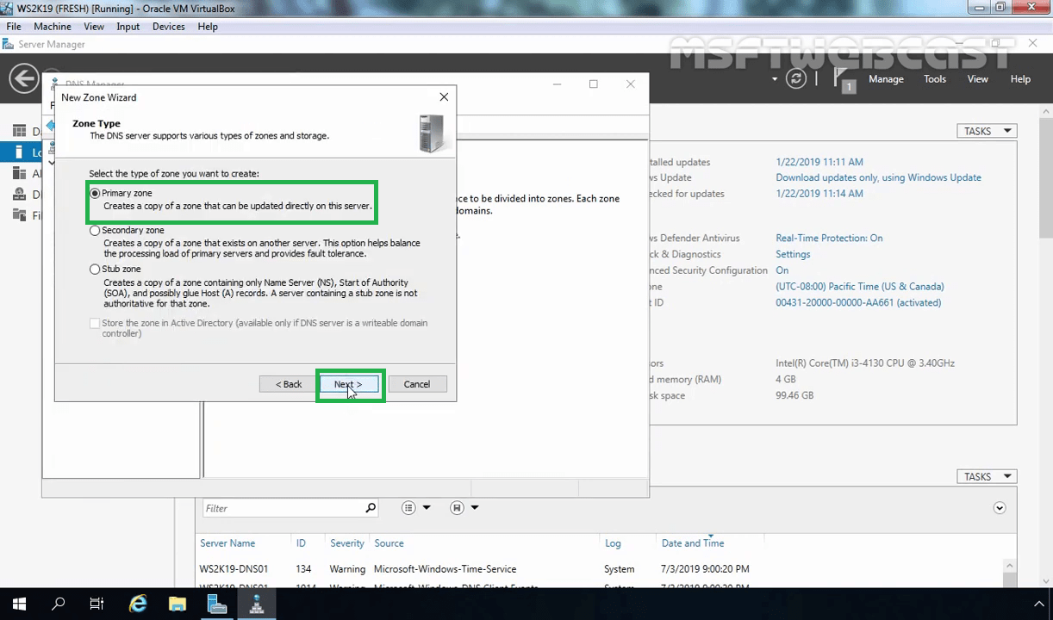
Select IPv4 Reverse Lookup Zone and click on next.
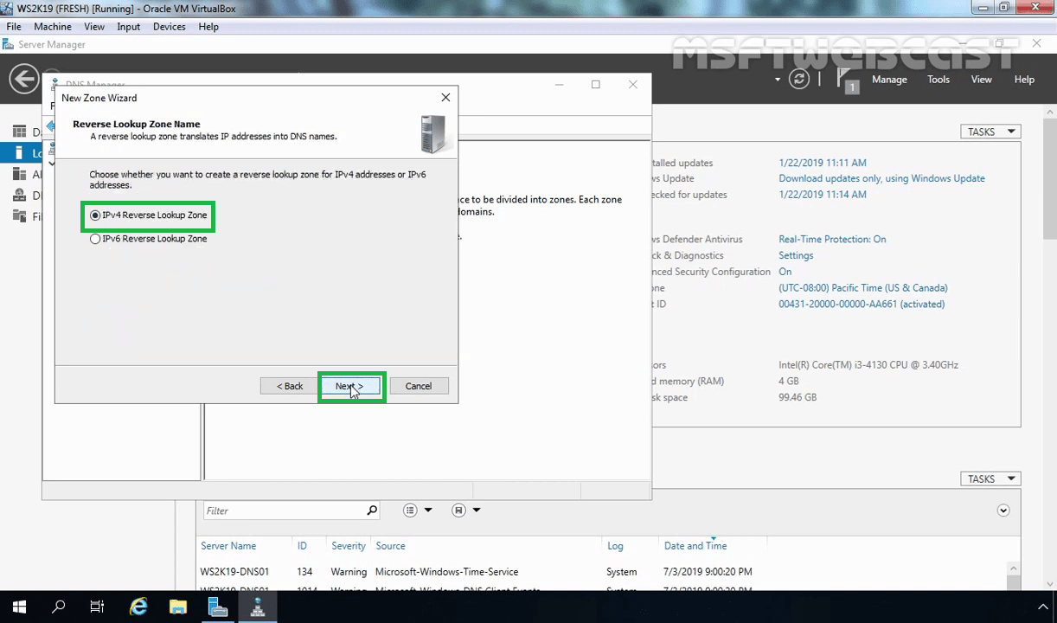
In Network ID field enter the first three octets of your DNS Server IP-address. (In our case, it will be 172.18.72.). Click on Next.
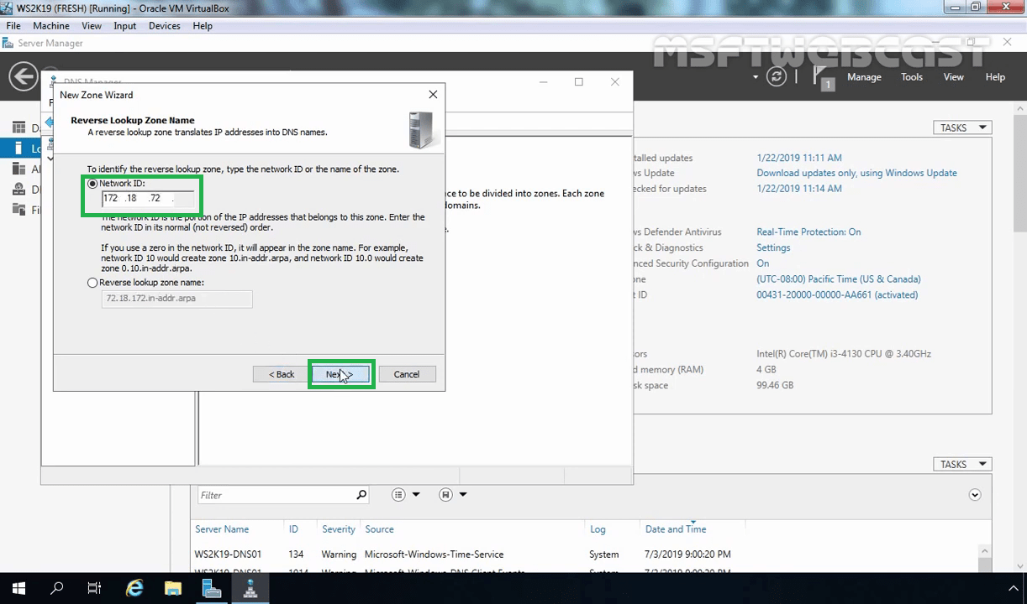
Click on Next.
Choose Do not allow dynamic updates and click on Next.
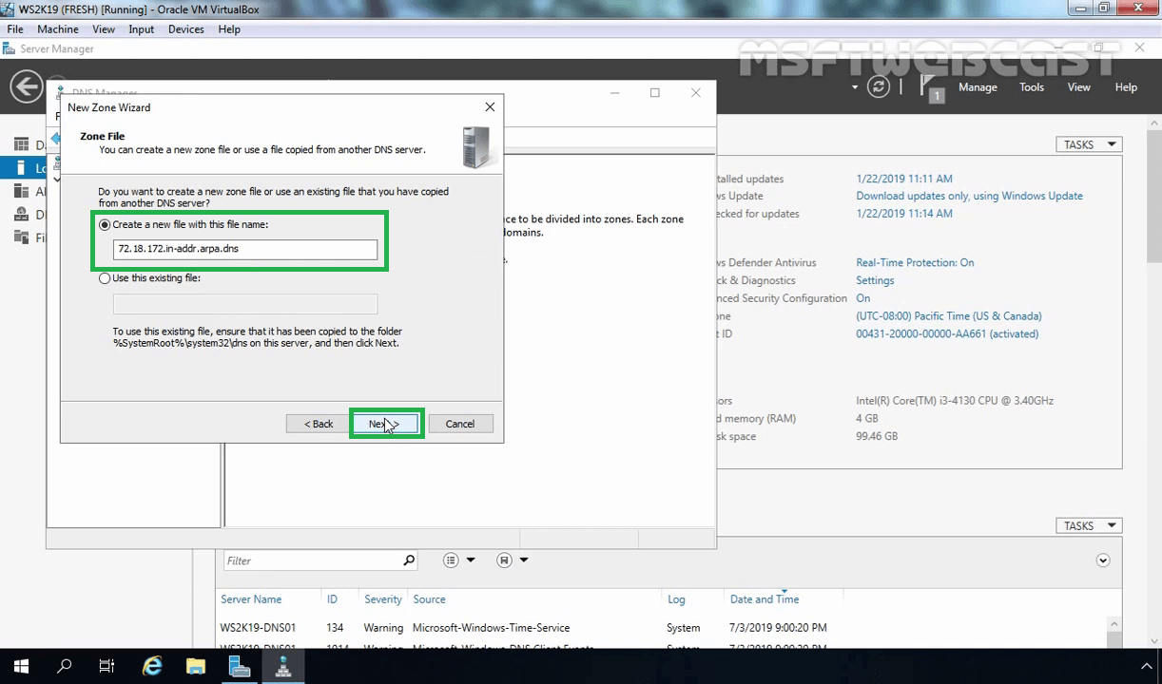
Click on Finish.
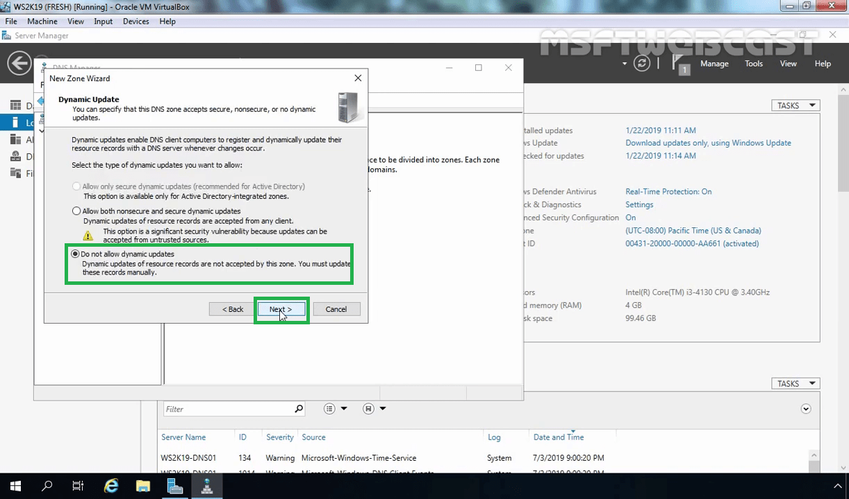
That’s all, Reverse Zone created.
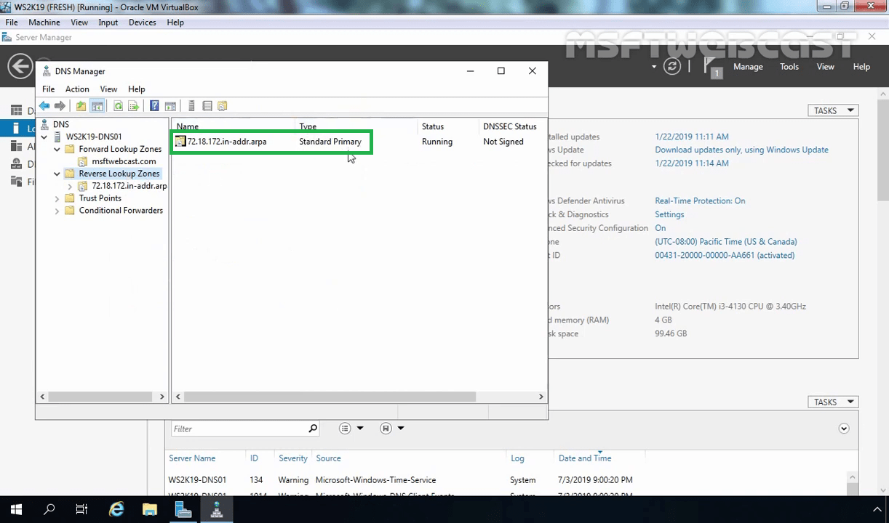
Add Host Record in a Forward Lookup Zone:
Right-click your forward lookup zone (In our case, right-click on msftwebcast.com) where you would like to create a host record and select New Host (A or AAAA) record.
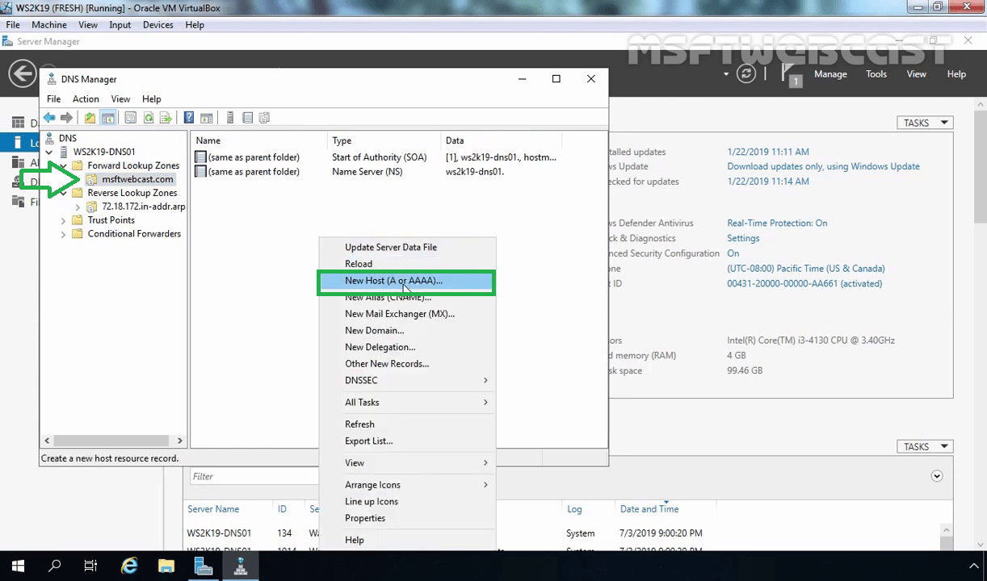
Here type the name (ws2k19-dns01) and IP-address (172.18.72.5) of your DNS Server in appropriate fields and then click Add Host.
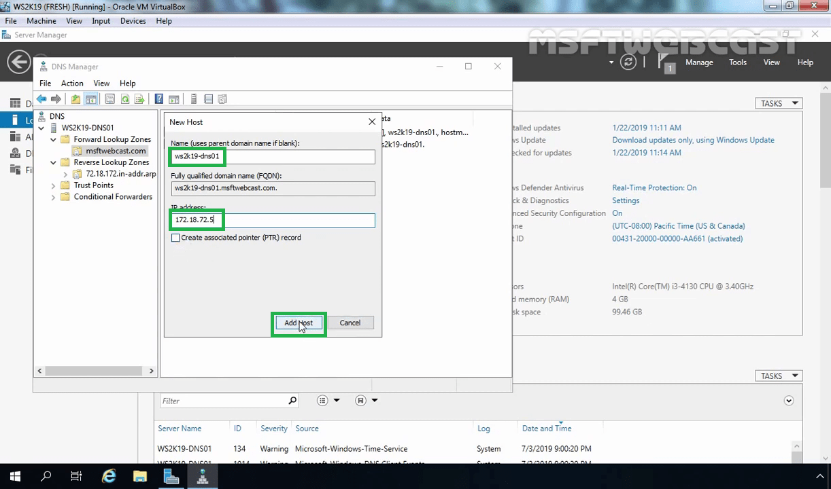
A message appears stating that the record has been created. Click on OK to close the message.
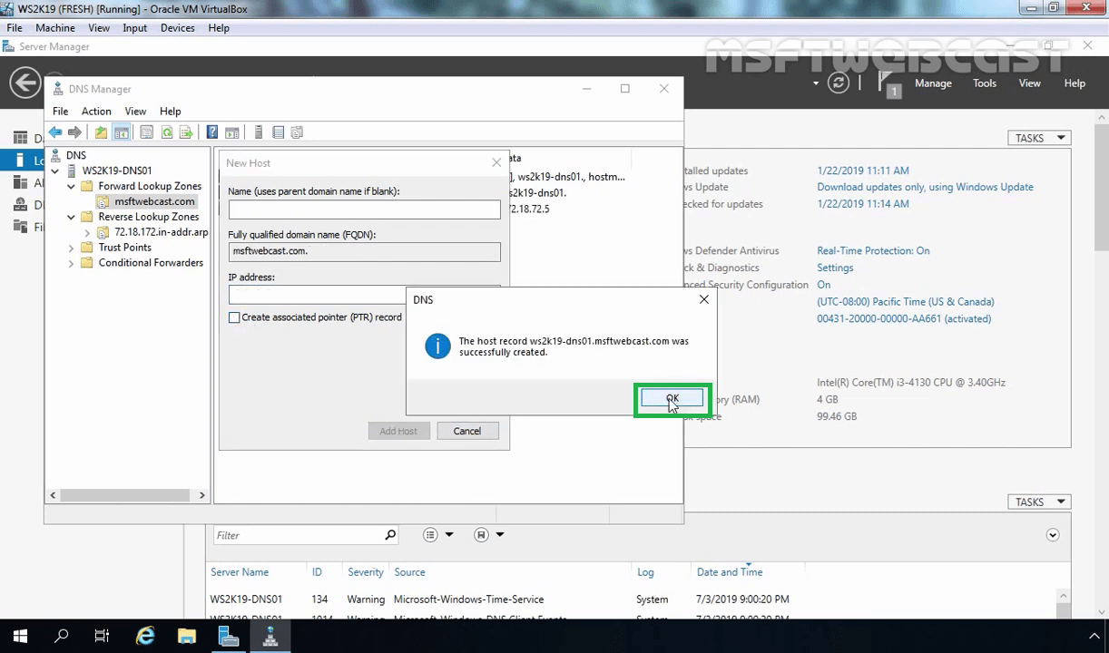
You can verify new host record under forward lookup zone.
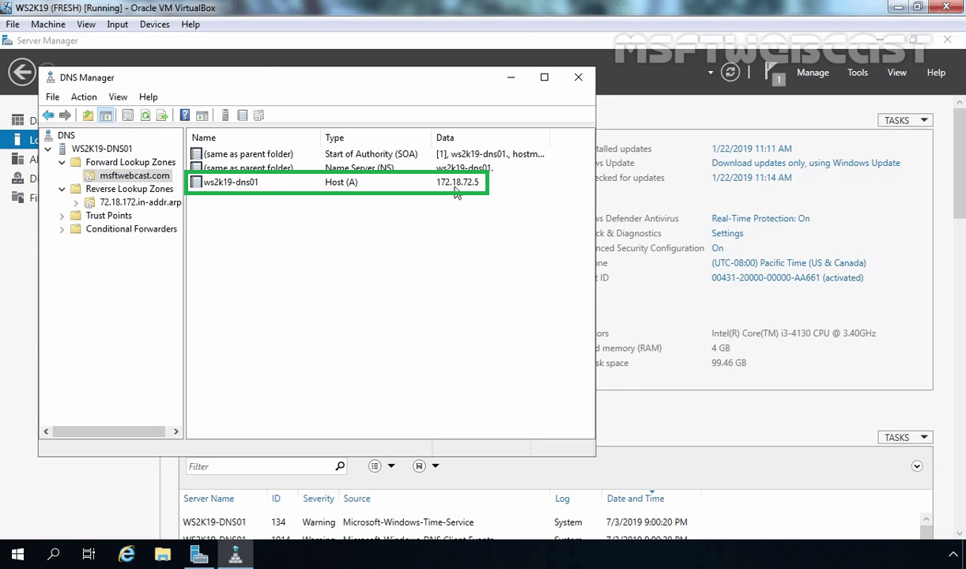
Add Pointer Record in a Reverse Lookup Zone:
Right-click your forward lookup zone where you would like to create a pointer record and select New Pointer (PTR) record.
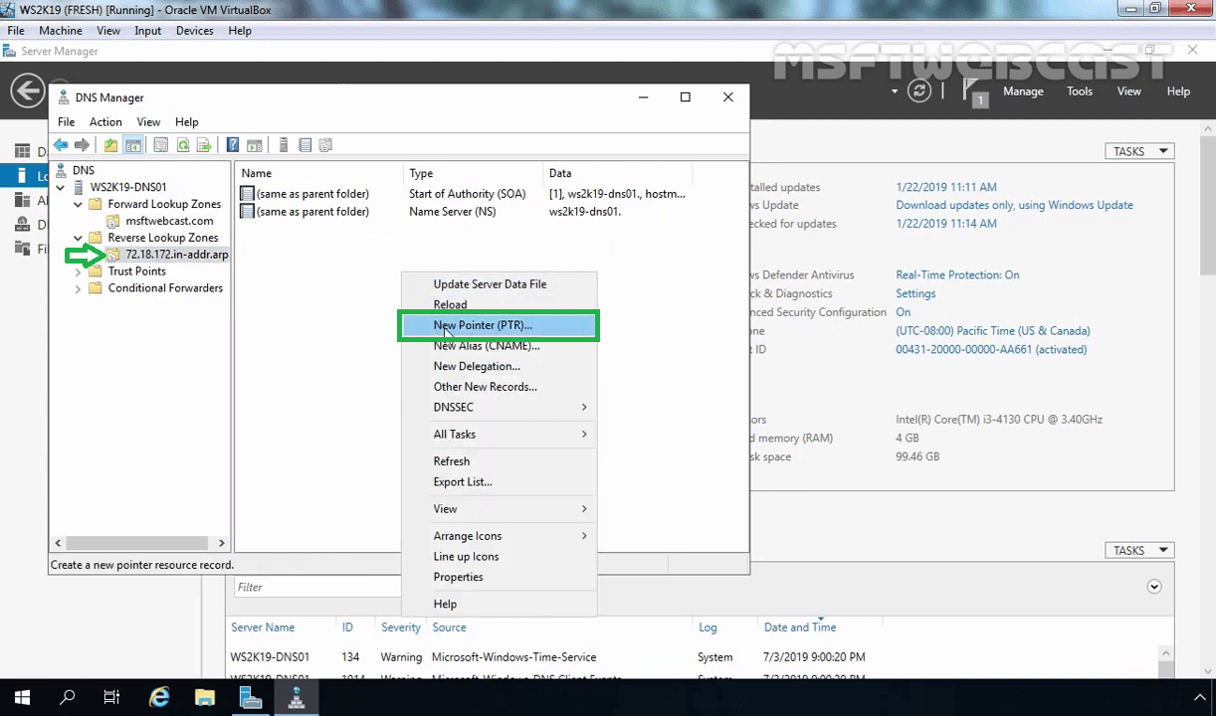
Type the IP-address (172.18.72.5) and host name (ws2k19-dns01.msftwebcast.com) of your DNS Server in appropriate fields and then click on OK.
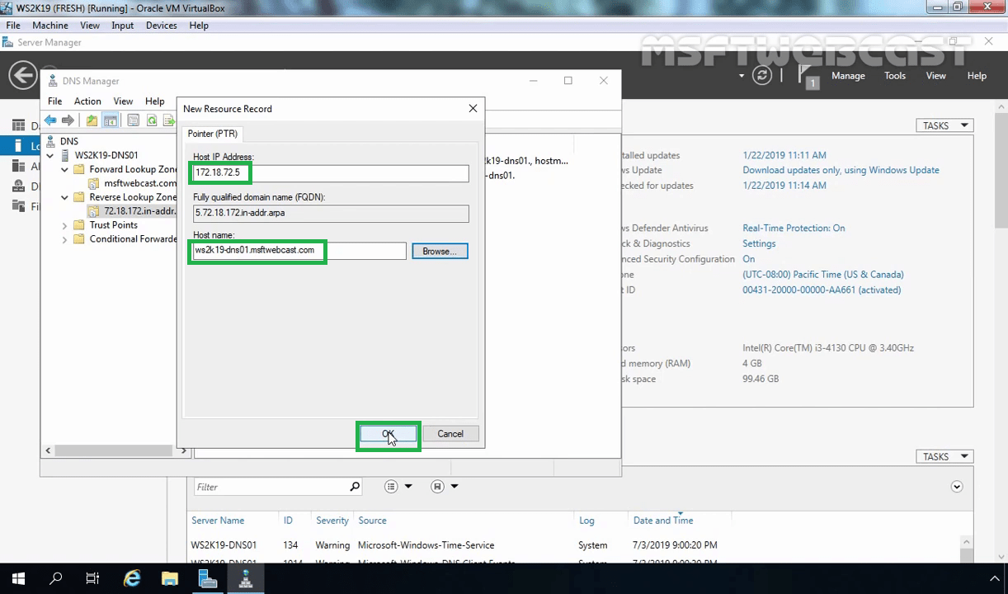
That’s it, Pointer record is also created successfully.
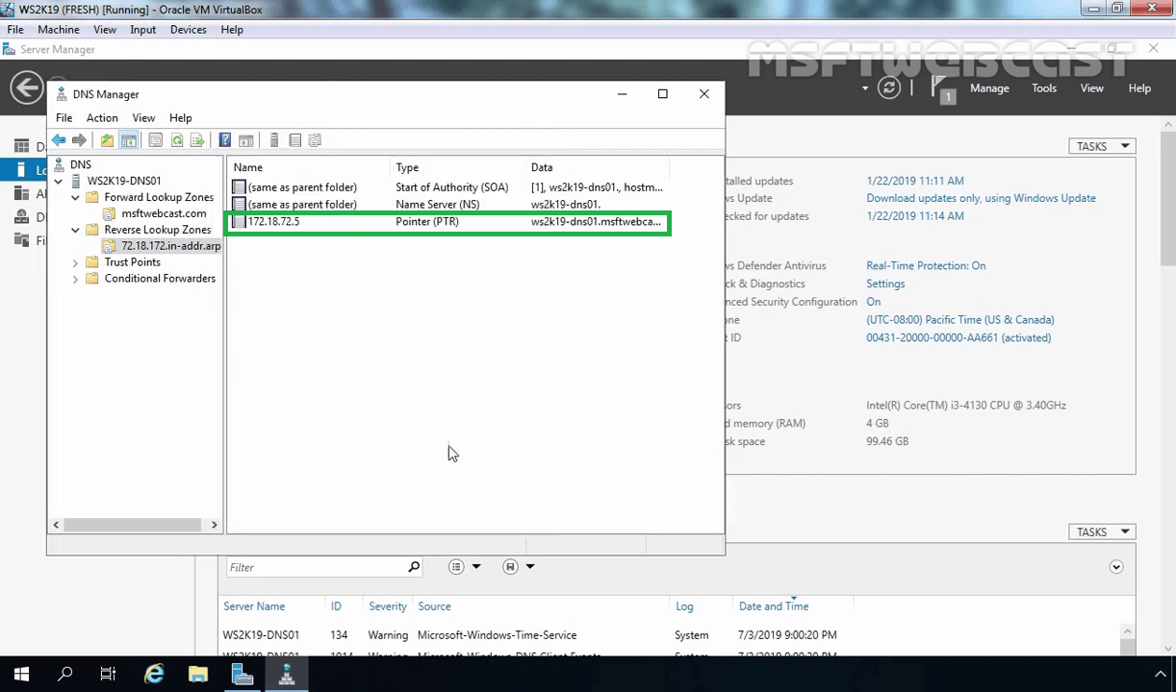
Launch nslookup:
Right-click on DNS server and select launch nslookup.
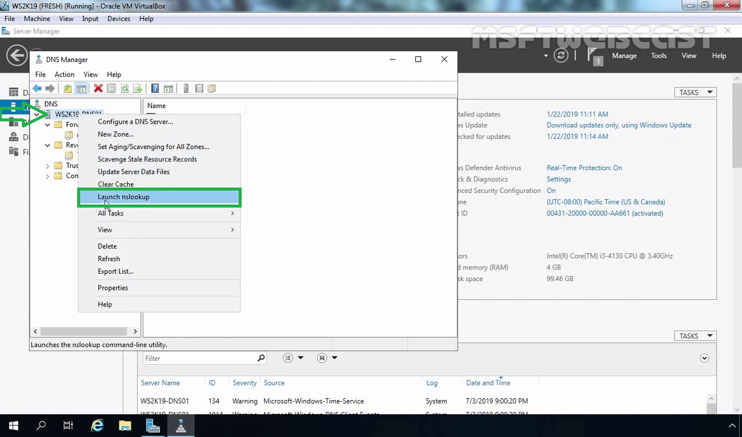
If you have a host record and pointer record for your DNS server, then you will be the below screen.
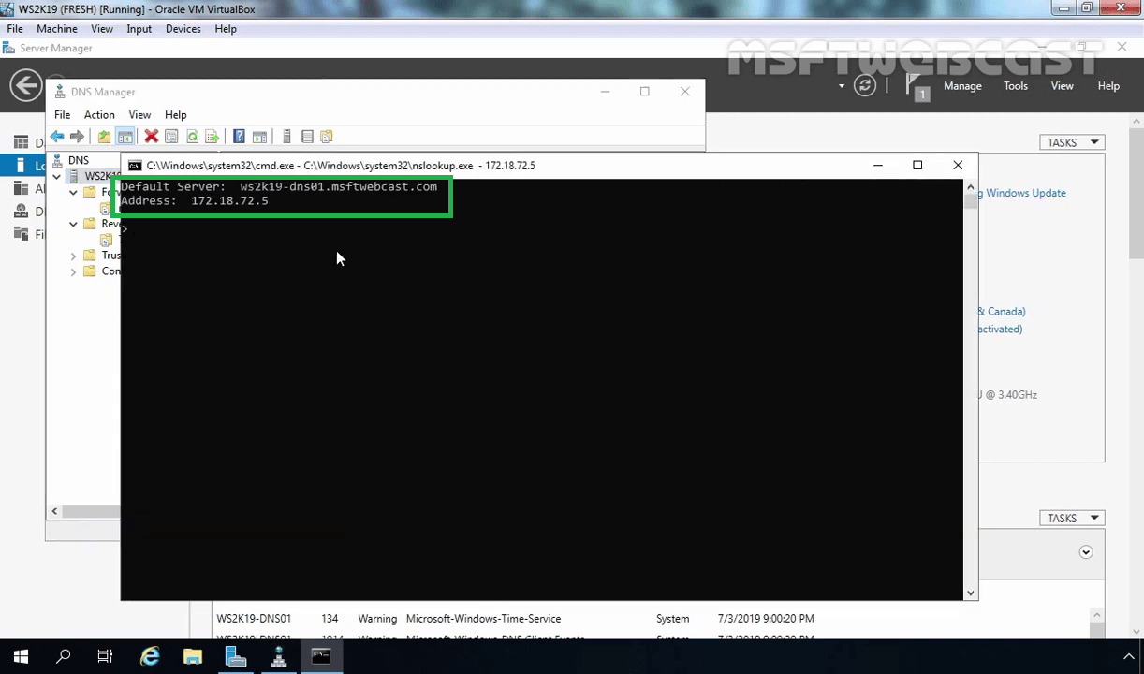
This means our DNS server is configured properly and working perfectly fine.
In this post, we have discussed how to install and configure the DNS Server role on Windows Server 2019

