**How to Configure a DNS Forwarder on Windows Server 2019**

**Why Configure a DNS Forwarder?**

Configuring a DNS forwarder on your Windows Server 2019 can enhance the efficiency and security of your network. It allows your internal DNS server to forward DNS queries for external domains to an external DNS server. This approach improves the speed and reliability of resolving internet domain names and reduces the load on your internal DNS server. Additionally, it helps protect your internal network from unauthorized access by external users.

**Step-by-Step Instructions:**

1. **Open DNS Manager:**
   * Launch the DNS Manager from the Windows Server Manager.

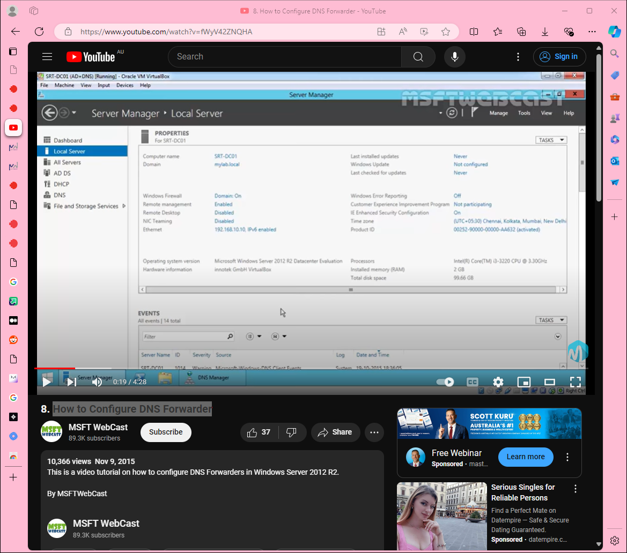

1. **Clear Existing Cache (Optional):**
   * Navigate to your DNS server in the DNS Manager.
   * Right-click your server name and select "Clear Cache."
2. **Check Initial Configuration:**
   * Ping an external domain (e.g., google.com) to confirm it's currently not resolvable.
   * Ping an internal domain (e.g., yourdomain.local) to confirm it's resolvable.

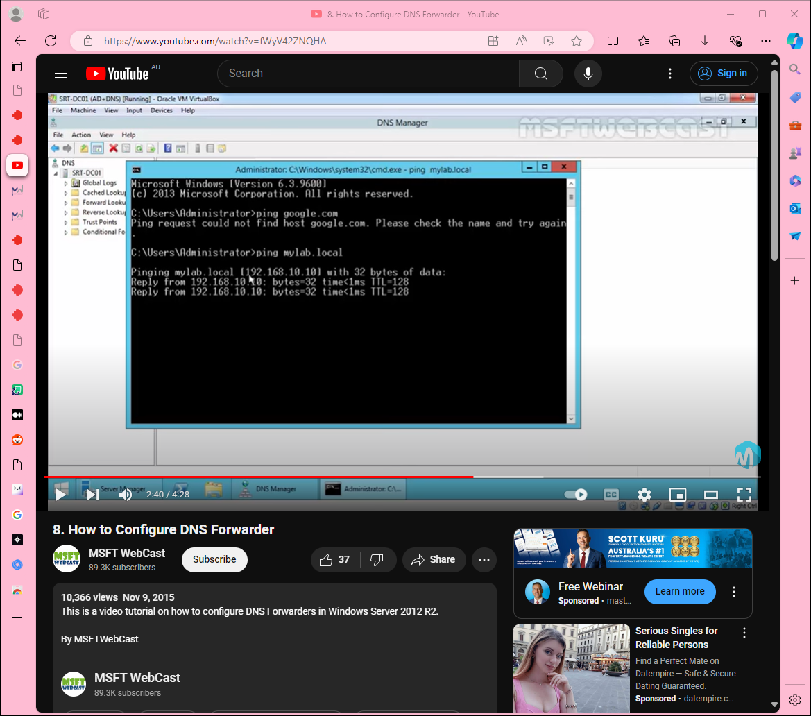

1. **Configure DNS Forwarder:**
   * Right-click your DNS server name in the DNS Manager and select "Properties."
   * Navigate to the "Forwarders" tab.
   * Click the "Edit" button.
2. **Add Forwarder Address:**
   * In the "Edit Forwarders" dialog, enter the IP address of the external DNS server you want to use (e.g., 8.8.8.8 for Google's public DNS).
   * Click "OK."

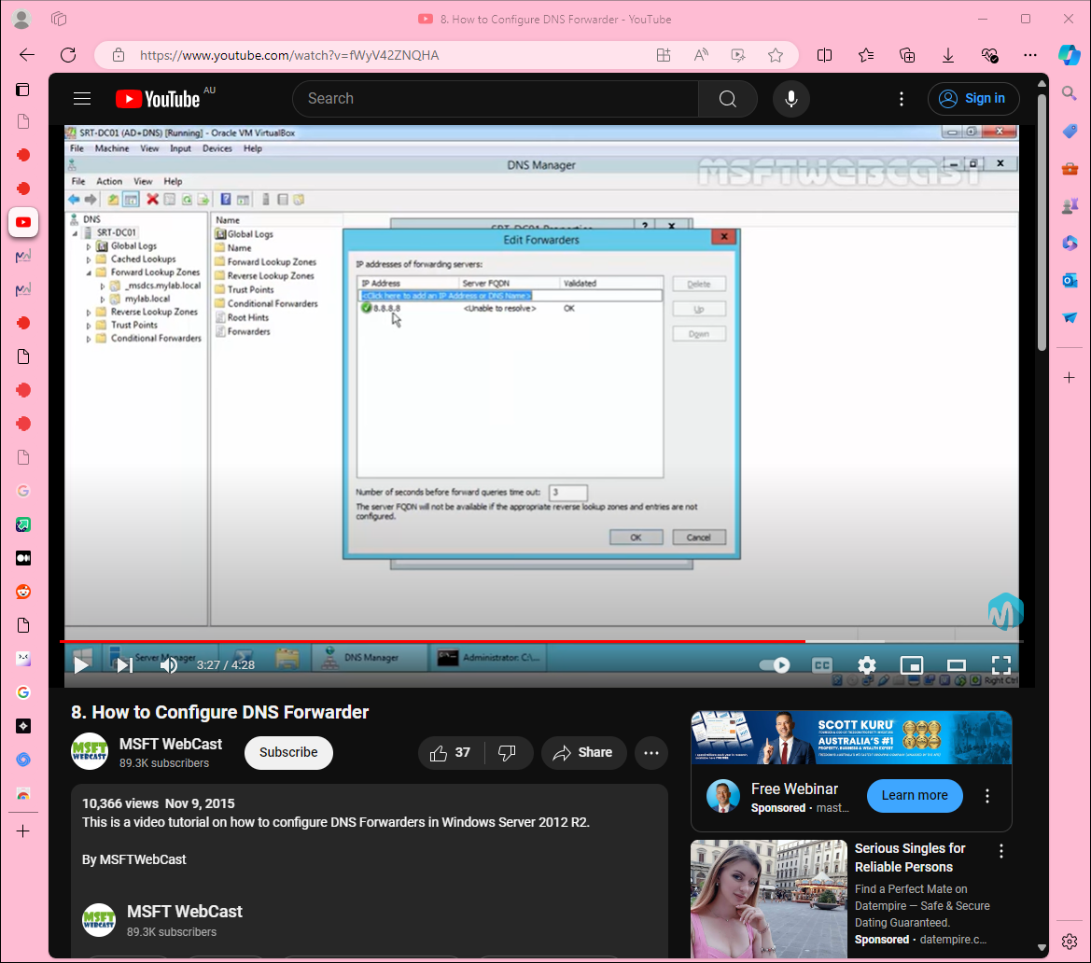

1. **Apply Changes:**
   * Click "Apply" and then "OK" to save the configuration.
2. **Test the Configuration:**
   * Ping an external domain (e.g., google.com) again to confirm it is now resolvable.
   * Verify the IP address resolution (e.g., 216.58.x.x for google.com).

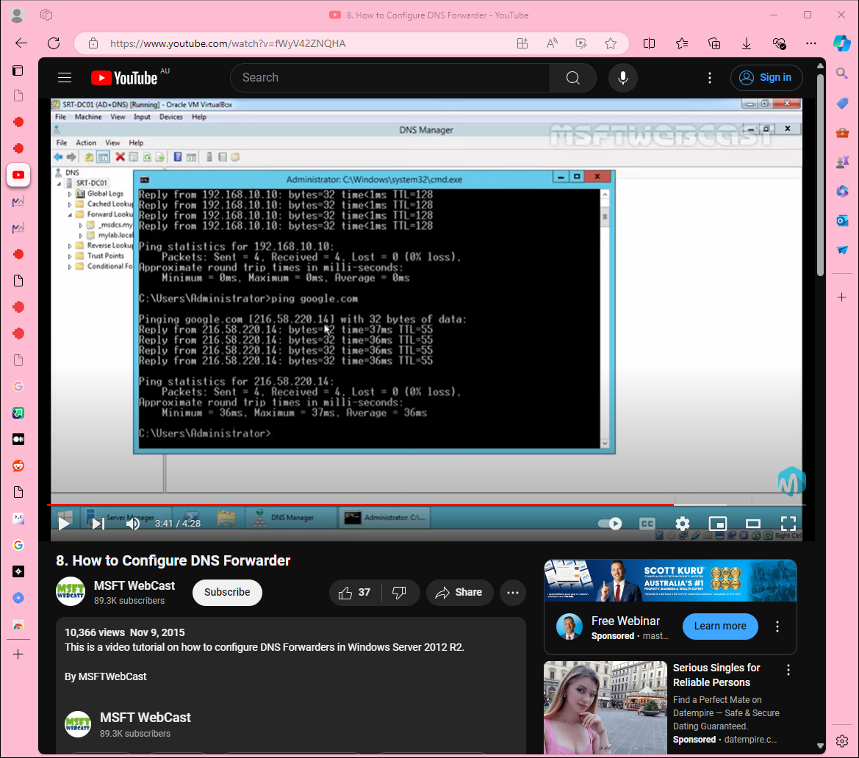

1. **Check DNS Cache:**
   * In the DNS Manager, navigate to the "Cache" section under your DNS server.
   * Expand the "Cache" node to see the cached DNS entries.

**Summary:**

* **Efficiency:** Forwarding DNS queries to an external DNS server reduces the processing load on your internal DNS server.
* **Speed:** The forwarder's cache helps speed up the resolution of frequently accessed external domains.
* **Security:** By using a DNS forwarder, you can better protect your internal network from unauthorized external access.