Choose only one of the following valid inputs to perform for test 1 (allow authorised):
- Entering numbers greater than 14 for the age
- Entering the value yes for the student card to charge $50.00 for the video game.
- Entering the value no for the student card to charge $100.00 for the video game.

Choose only one of the following invalid inputs to perform for test 2 (blocking unauthorised):
- Entering numbers less than 15 for the age
- Entering letters for the age
- Entering special characters for the age
- Entering values other than yes and no for the student card

How the tests are being conducted (5-15 words per test) | Test Debug Screenshot | Modifications Required (10-15 words per test)
Test 1 (allow authorised):  Age = 25 | 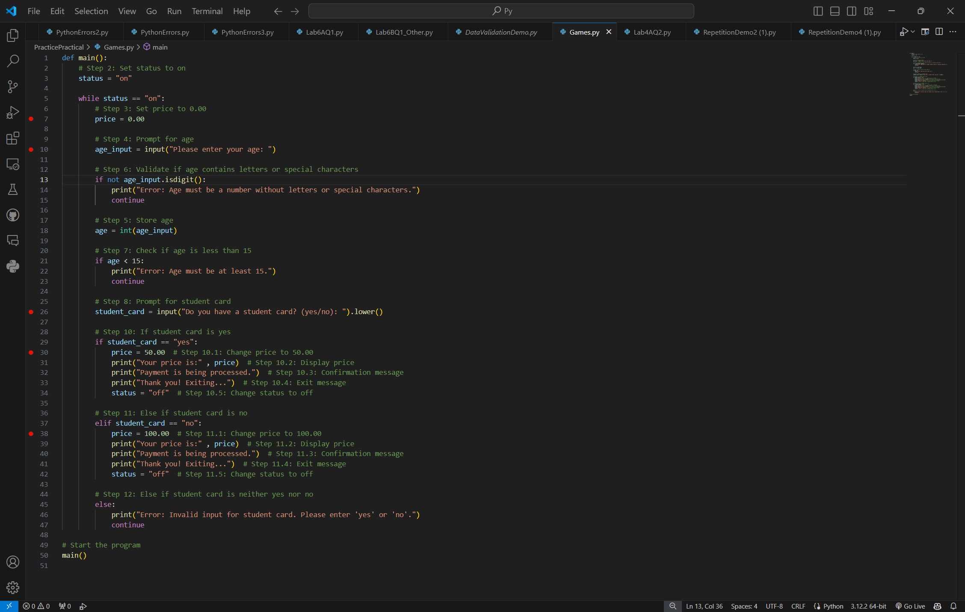 | 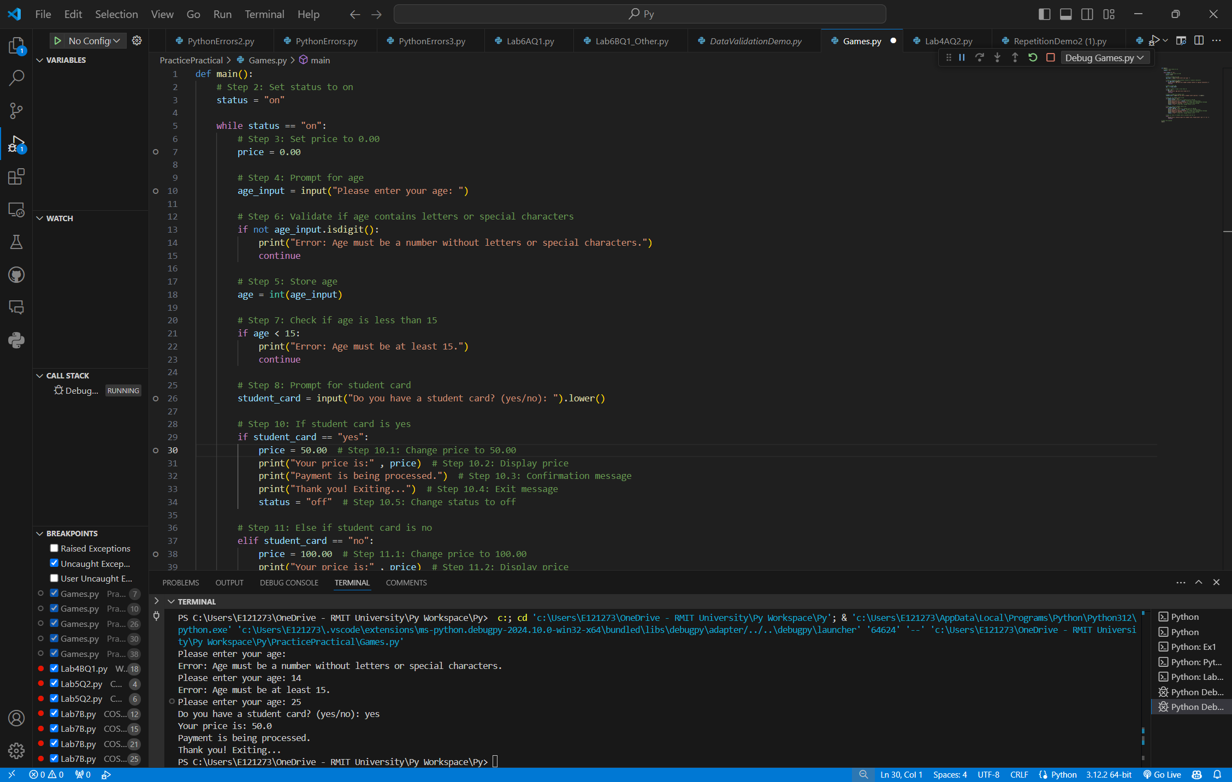  None
Test 2 (blocking unauthorised):  Age =14 | 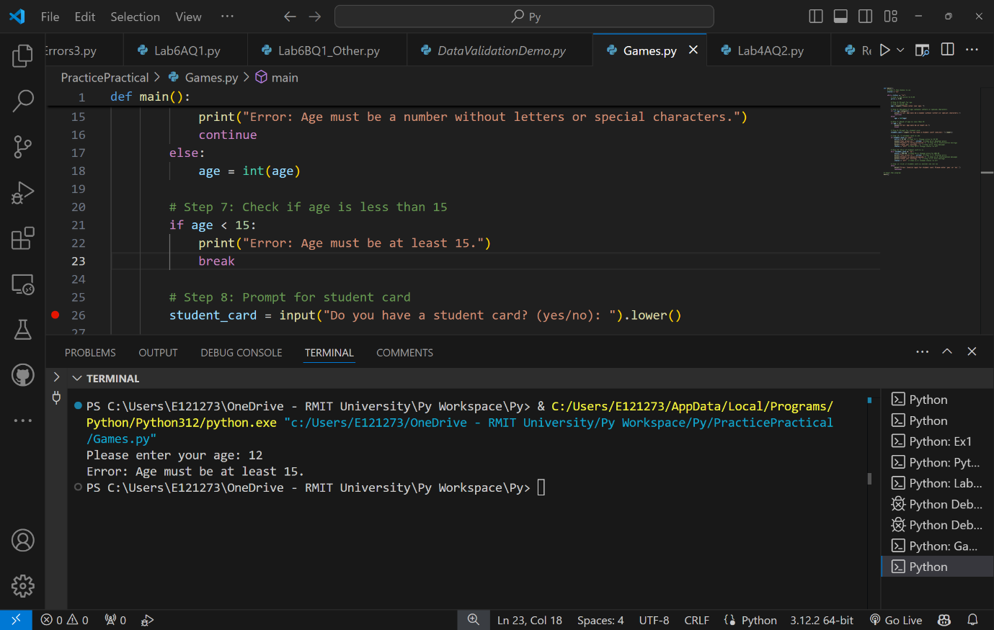 | None since the program produce an error

