Scripting Project  
Assessment Task 2

Certificate IV in Cyber Security

Write scripts for software applications

Semester x 20xx

Written by X

Student number: x

Contents

Task 2 1

Task 3 3

Task 4 4

Task 5 5

# Task 2

You will then write a report in which you:

a)

i)Identify the framework

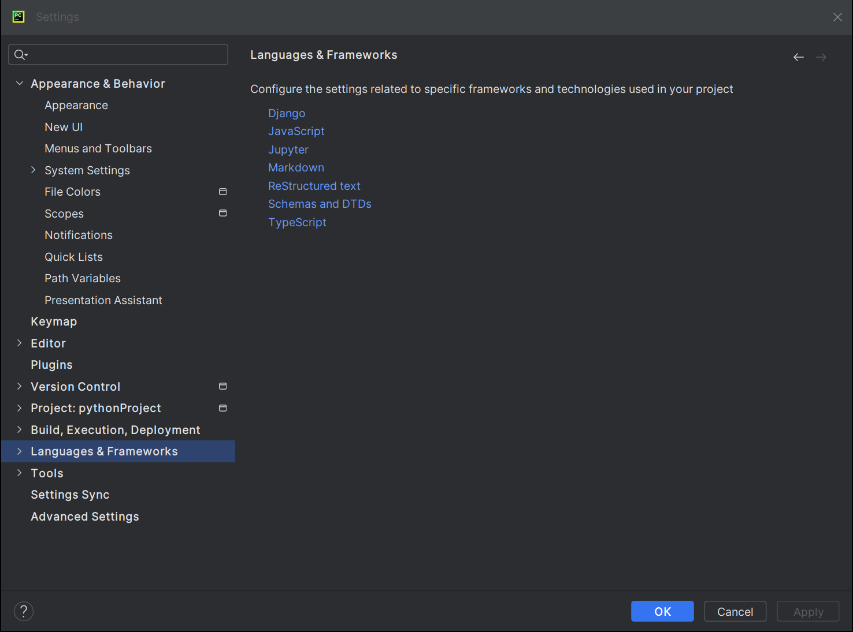

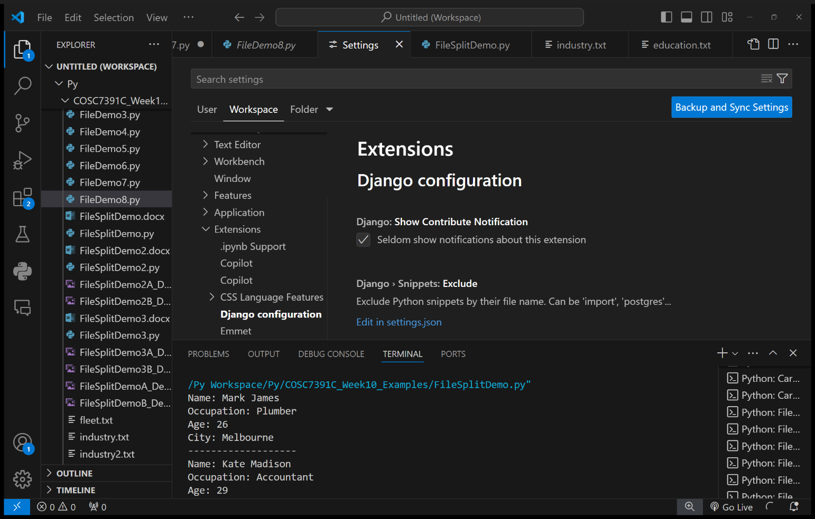

[Top Python Frameworks| Python Framework List - Javatpoint](https://www.javatpoint.com/python-frameworks#:~:text=There%20are%20mainly%20three%20types,various%20kinds%20of%20Python%20frameworks.)

ii)integrated development environment (IDE) used to develop the script,

iii)listing the limitations of this choice and explaining why it still meets your needs.

b)

i)Identify the protocols

https://mypy.readthedocs.io/en/stable/protocols.html

ii)object model used in the chosen scripting language.

http://joeyhejna.com/notes/programming/python/1objectmodel/

# Task 3

a) Document an overview of the logic required in your algorithm (e.g.: an overview of what the main stages/blocks of the algorithm will do) to meet the requirements from task 1.

- algorithm

b) Create an algorithm (written in pseudo code) that will meet the requirements obtained from task 1. Include in your script the use of item manipulation.

- pseudo code

# Task 4

* Attach py file as well when you submit on canvas
* Use correct syntax for the language as specified in the technical documentation of the programming language · Use variables with appropriate data types for storing the inputs entered by the user, including the use of a list where appropriate · Use selection constructs with expressions or ‘try’ blocks to validate the inputs entered by the user · Use iteration constructs for continuously running the script until the exit option is entered by the user
* Use exception handling as appropriate to meet client requirements from task 1

# Task 5

a) Giving instructions for running the software application in the IDE.

b) Providing steps for entering valid inputs into the software application.

c) Provide sample output displayed for valid example input, and explaining the output.

d) Explain each possible error message produced by the software application and the situation that would cause it to be displayed.